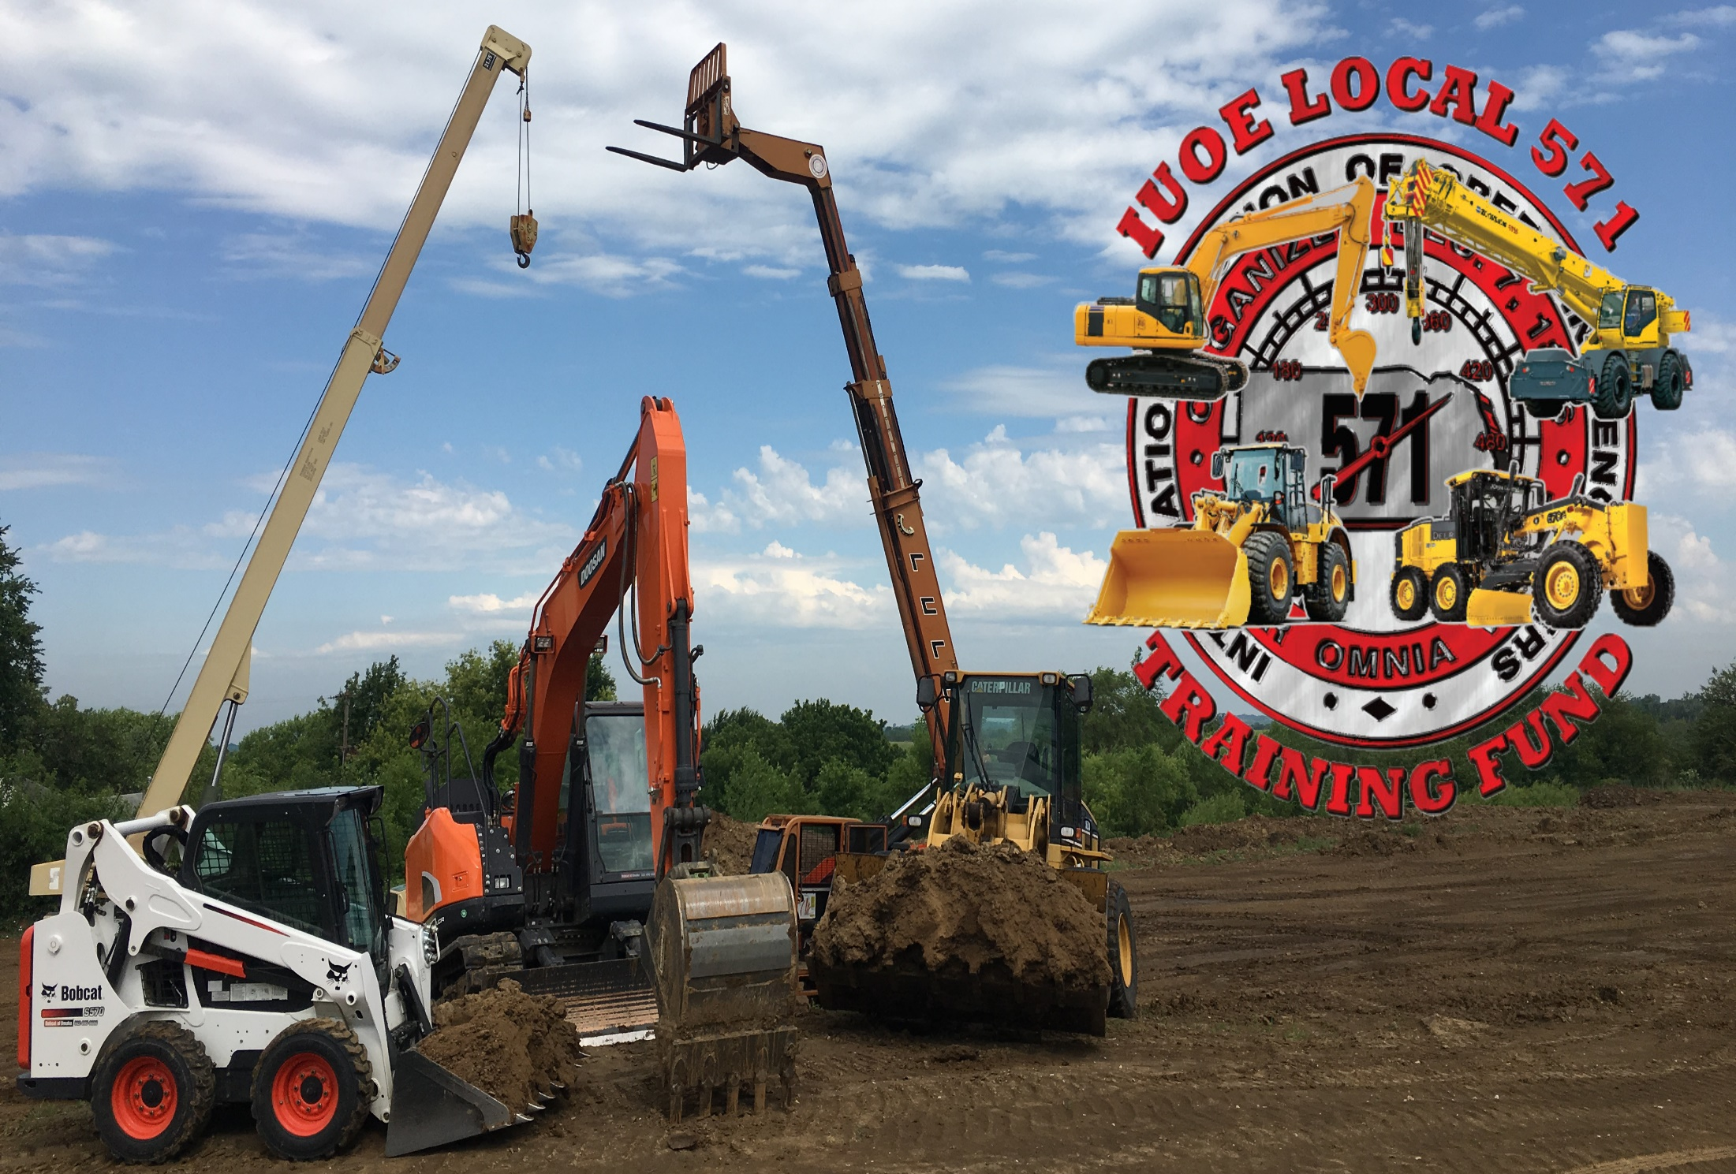
July
4-6 Thu Site Closed Fourth of July
11 Thu 7PM Union Meeting
12 Fri 6PM Mandatory Apprentice Training
Selected apprentices will be notified
Subject TBA
13 Sat 8AM Mandatory Apprentice Training
Selected apprentices will be notified
Subject TBA
20 Sat 8AM First Aid CPR AED
24 Wed 6PM NCCCO Practical Exam Prep

August

8 Thu 7PM Union Meeting
10 Sat 8AM First Half 10hr OSHA
14 Wed 6PM NCCCO Practical Exam Prep
17 Sat 8AM Second Half 10hr OSHA
23 Fri 6PM Mandatory Apprentice Training
Selected apprentices will be notified
Subject TBA
24 Sat 8AM Mandatory Apprentice Training
Selected apprentices will be notified
Subject TBA
28 Wed 6:30PM Unionism Education
31 Sat Site Closed/Mandatory Apprentice Labor Day Parade Prep

September

1-2 Sun-Mon Site Closed Labor Day Weekend
12 Thu 7PM Union Meeting
18 Wed 6PM NCCCO Practical Exam Prep
20 Fri 6PM Mandatory Apprentice Training
Selected apprentices will be notified
Subject TBA
21 Sat 8AM Mandatory Apprentice Training
Selected apprentices will be notified
Subject TBA
29 Sun 11AM !!!!OPEN HOUSE!!!!

Just a reminder, you must be a member in good standing to attend any
training sessions. Also, a $25 deposit check must be on file at the
Training Site before any member will be included on any class roster.
Make checks payable to:
IUOE Local 571 Training Fund
11404 North 72nd Street
Omaha, NE 68122
Checks will be returned after completion of the class. You may leave the
Check on file for future classes. If you do not attend a class you have
signed up for and do not call the Training Site to cancel, your check will
be donated to the Training Fund.

For all Journeypersons and Apprentices, even when there is a class
scheduled, the Training Site is open for anyone to utilize. Make sure
your cards are up to date. Bring your PPE with you to train. Do not
interrupt whatever class is currently in session. Call to register for
a class. We look forward to seeing you.

Updates will also be posted on our website:
http://iuoe571.org
Facebook: IUOE L-571 & IUOE Local 571 Training Fund

